Final Project - Site Map/Wireframe

NAME -Sahejpreet Singh

EMAIL – [Sahejpreetsingh5229@conestogac.on.ca](mailto:Sahejpreetsingh5229@conestogac.on.ca)

STUENT NUMBER – 8905229

Course Code – 1836

PROFESSOR NAME – Pratish Shelar

**Sitemap :**

Sitemap :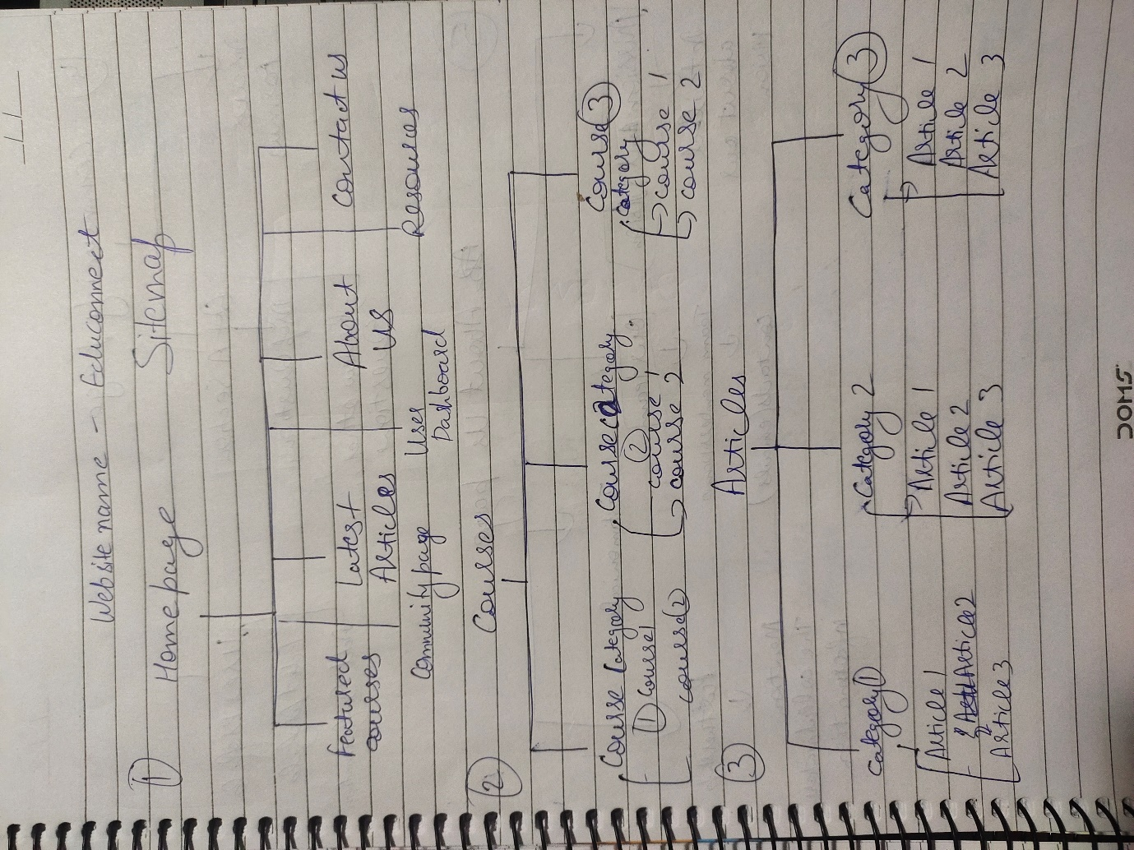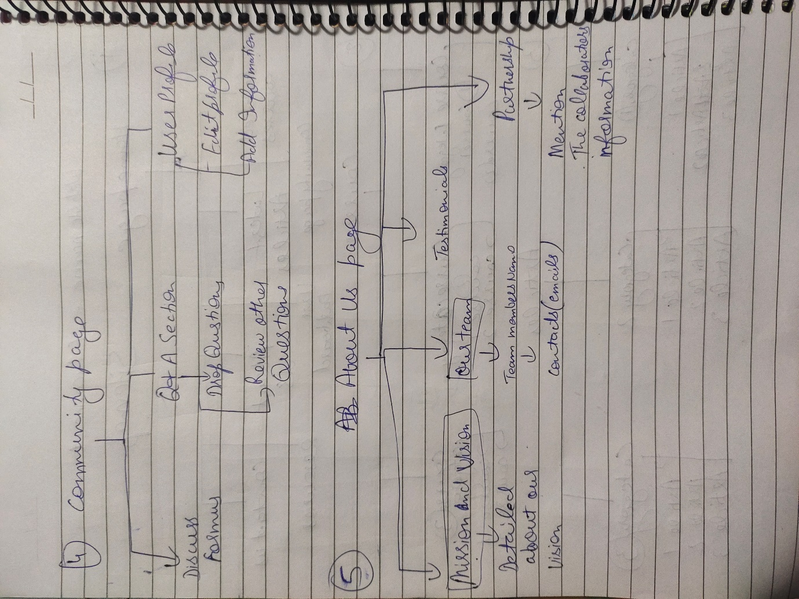

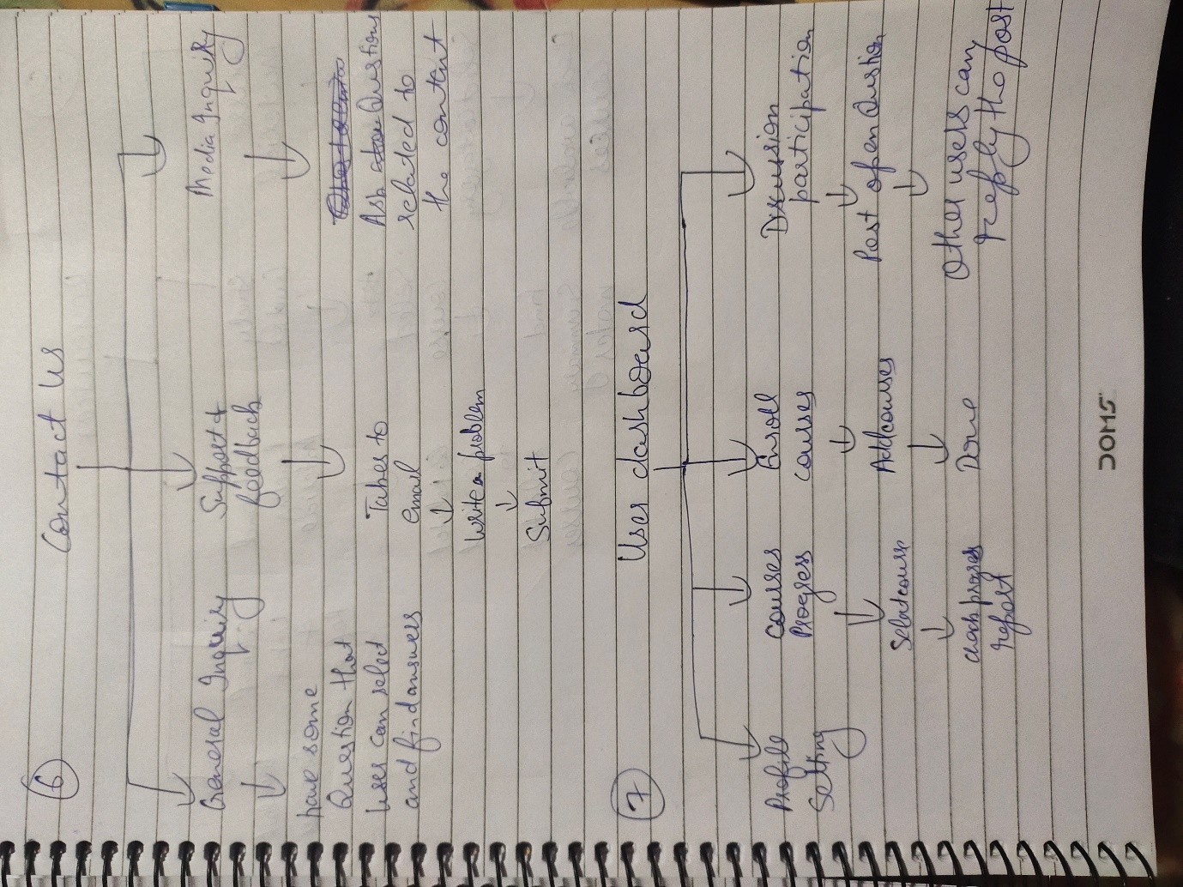

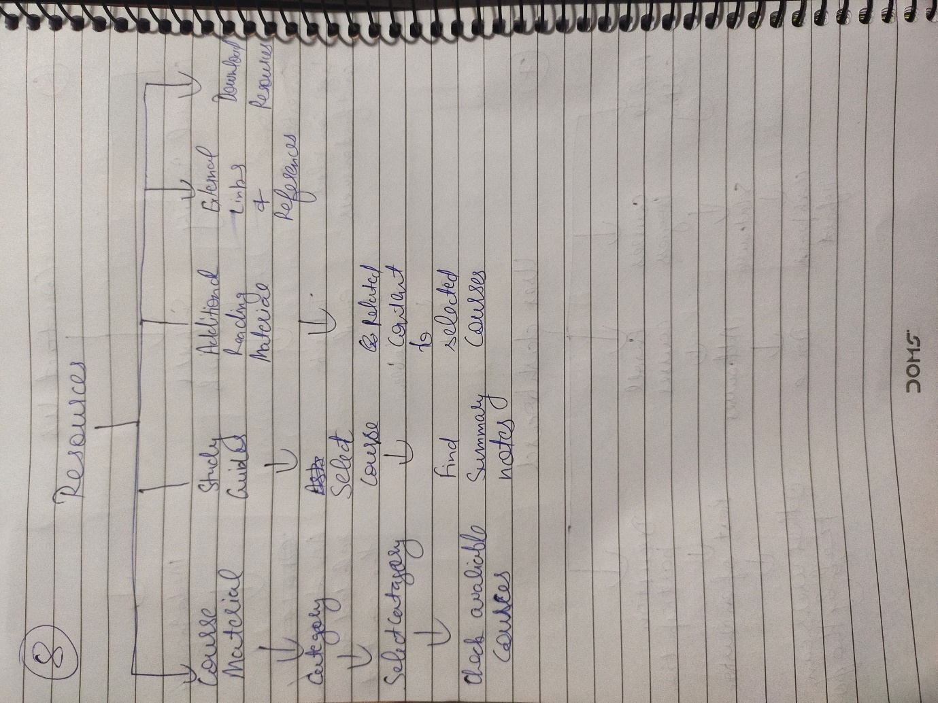

**Wireframe :**

